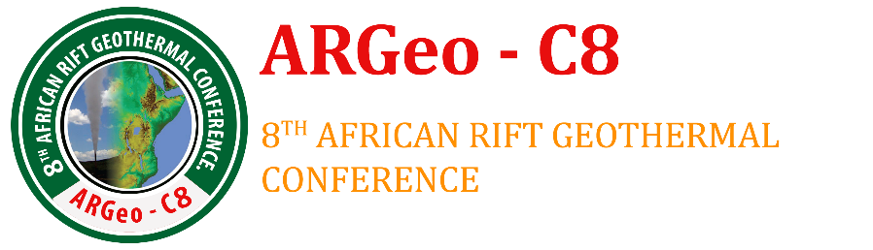
Outline for writing the Country update Paper
The following is the recommended outline for country update papers. The format should follow the earlier ARGEO conferences template sent as a separate file.
- Paper Title: Geothermal Development in (insert name of your Country) – a Country Update
- Abstract
- Should contain Summary of the report
- Introduction
- Introduction of your paper
- Status of Electricity Production (from all sources of energy)
- Current total installed and effective capacity
- Modes of generation and their contributions
- Contribution from geothermal (if any) should be highlighted
- Medium Term and Long Term Power development plan and the role to be played by geothermal in the achievement of the plans
- Status of Geothermal Development in the country
- Geological setting and map showing potential sites for geothermal development
- Results of surface exploration done
- Results of exploration, appraisal and production Drilling
- Results of well discharge tests and well out put
- Resource potential in the country
- Utilization (power production and direct use)
  - Provide a table with the following information – Power plant owner, plant location (field), plant type (binary, condensing, etc), manufacturer, year of commissioning, units, equipment rating, total plant capacity, plant capacity factor
  - Direct Use – where utilized and energy capacity if known
  - Power Plants planned for commissioning by 2020 (provide plant capacity and planned year of commissioning)
- Investment Opportunities
- Investment opportunities for potential investors
- Incentives offered to developers
- Outlook and Conclusions
- Conclusions and way forward
- References

